**CRM Deployment Automation Guide**

**Version Control**

|  |  |  |  |  |
| --- | --- | --- | --- | --- |
| **Version** | **Date** | **Author** | **Reviewer** | **Change Summary** |
| 0.1 | 25/08/2023 | Vinod Junghare | Pallavi Mauskar | Initial Draft |
| 0.2 | 28/08/2023 | Vinod Junghare | Pallavi Mauskar | Added below Sections:  Gitlab User token Creation  Adding Credentials in Jenkins |
| 0.3 | 29/08/2023 | Vinod Junghare | Pallavi Mauskar | Updated documents for cosmetic changes, changed font to VF Rg. |
| 1.0 | 30/08/2023 | Vinod Junghare | Pallavi Mauskar | Final Draft |
| 1.1 | 11/09/2023 | Shraddha Dhumal/Vinod Junghare | Pallavi Mauskar | Added Report generation section |

Table of Contents

**CRM Files in Gitlab** 2

**Gitlab User token creation** 4

**Adding Credentials in Jenkins** 6

**Nexus Upload Pipeline** 8

**E2E Deployment Pipeline** 10

**Individual Module Deployment Pipelines** 11

**PET Deployment Pipeline** 12

**Report Generation Pipeline** 12

# **CRM Files in Gitlab**

Below tables provides information on Gitlab Repo & branch details used in different CRM pipelines.

* Gitlab Repo used here is - <http://devops01.connex.ro:9080/gitlab/autodeployment/3c.git>
* The Repo contains 4 branches where code & files used for different pipelines has been kept.

|  |  |  |  |
| --- | --- | --- | --- |
| **Branch** | **Branch Purpose** | **File** | **File Purpose** |
| develop | This branch contains files used for CRM NEXUS upload pipeline.  It mainly contains Jenkinsfile where all necessary pipeline code resides along with important scripts used during pipeline execution. | UploadToJenkins | This file copies release artifacts (unformatted) from Alonso server to Jenkins Workspace for further usage. |
| UploadToNexus | This is important file which contains core logic to versionize artifacts & load to nexus. |
| Jenkins/Jenkinsfile | This file contains Jenkins pipeline code & uses rest of the file to fulfill logical requirements. |
| Deployment | This branch contains files used for CRM deployment pipeline.  It is used in both CRM_deployment as well as CRM_Module_Deployment pipelines | CRM_Deployment/Environment.txt | File contains static information of Environments & usernames to be used for each environment server based on application. |
| CRM_Deployment/CRM_Deployment.txt | File contains static information of the application and its deployment path. These are used in pipeline during copy and deployment purpose. |
| Jenkins/Jenkinsfile | File contains pipeline code and core logic to copy & deploy application as per requirements & different servers. |
| PETDEPLOYMENT | This branch contains file used for CRM Full Release deployment pipeline. | CRM_Deployment/Environment.txt | File contains static information of Environments & usernames to be used for each environment server based on application. |
| CRM_Deployment/CRM_Deployment.txt | File contains static information of the application and its deployment path. These are used in pipeline during copy and deployment purpose. |
| CRM_Deployment/DB_Deployment.txt | File contains static information of the DB details specially for PET, information is used in during pipeline execution to copy over and perform SQL deployments. |
| OmsEarChange | This folder contains specific files that are used to update an ear with PET server information before deployment.  Specific ear called omsserver_weblogic.ear is unpacked, internal files are replaced by the files from folder and then packed again. |
| Omsear.sh | This shell script contains code to update ear file using files from above OmsEarChange. |
| Jenkins/Jenkinsfile | File contains pipeline code and core logic to copy & deploy application as per requirements & different servers. |
| ReportGeneration | This branch contains file used CRM release report generation. | ReportGenerator.sh | This shell script contains code to generate latest sub release report for given input major release. |
| Jenkins/Jenkinsfile | File contains pipeline code to invoke ReportGenerator shell and send mail to respective participant for given release |

# **Gitlab User token creation**

* For Jenkins to communicate with GitLab, a user access token needs to be created. Gitlab does not allow simple user/password logins anymore.
* This token can be set to expired as per requirement with a default timeline of 1 year as expiry.
* Below process shows process of user creation in Gitlab
  + Login to Gitlab with authorized user.
  + Click on Blue icon & then on preferences tab.

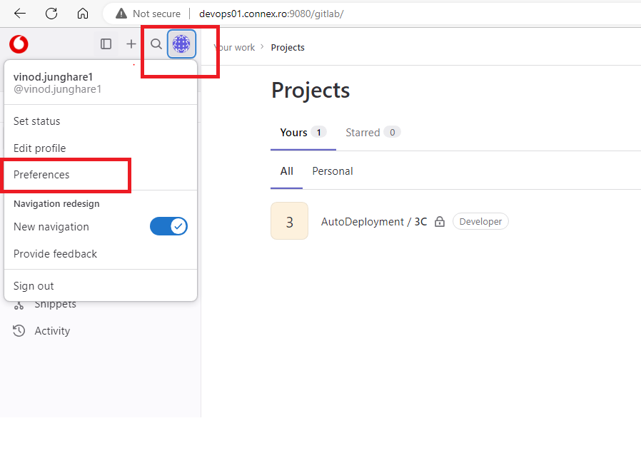

* Once into preference clink on Access token on the left panel

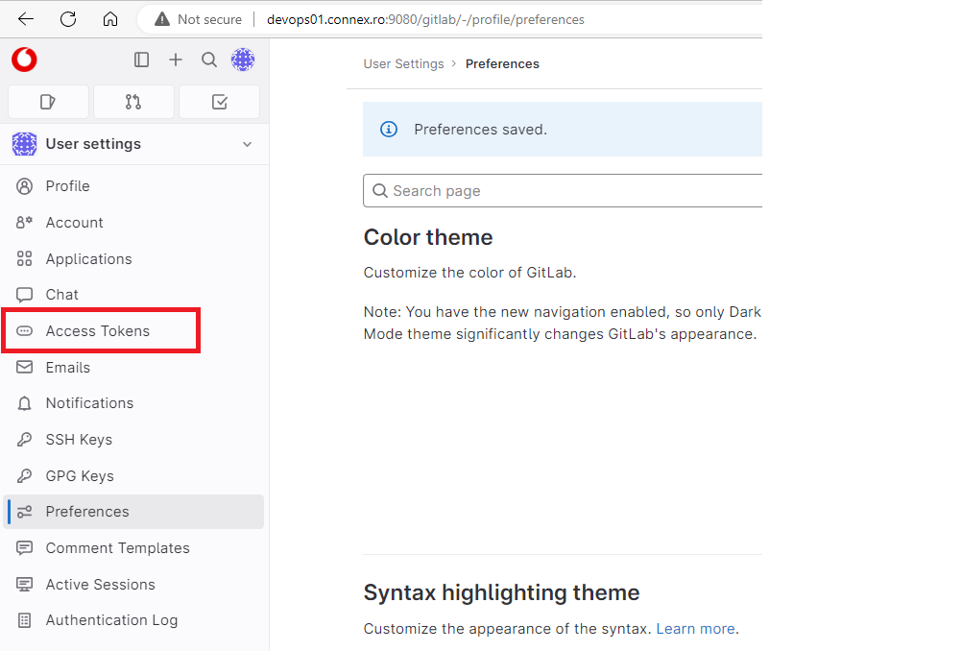

* On Personal access token screen, select all the access, provide the token name and click on generate token.
* The created token can be observed under personal access token.
* Please make sure to note and store it as once page is gone the token cannot be seen again, a new token must be created incase access token is missed or forgotten.

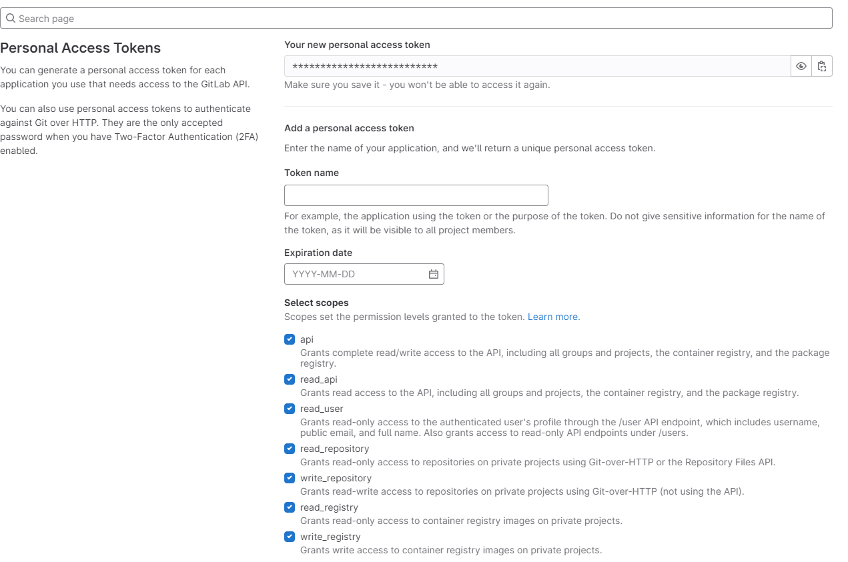

* The above created access token needs to be configured in Jenkins as credentials, which can then be used to communicate with Gitlab from Jenkins.

# **Adding Credentials in Jenkins**

* Process below to add credentials in Jenkins.
  + Login to Jenkins with authorized id, for adding credentials in Jenkins elevated access is required.
  + Click on Manage Jenkins

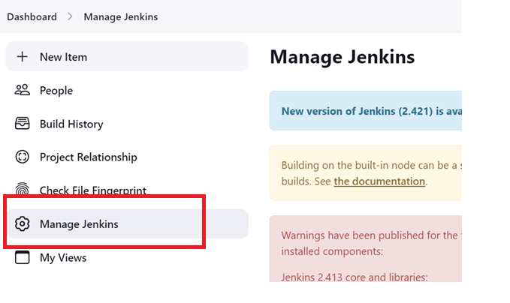

* Once in Managed Jenkins page, click on credentials

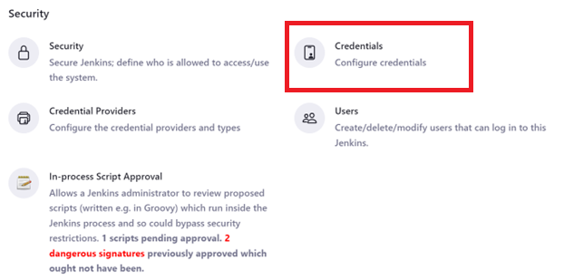

* Search for system and click on the global domain.

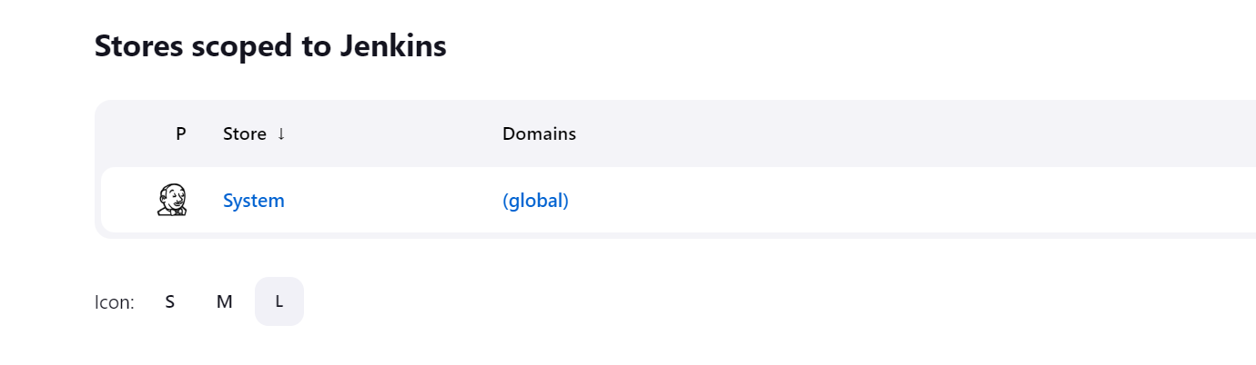

* On Global credentials page, you will be able to see “Add Credentials” option.

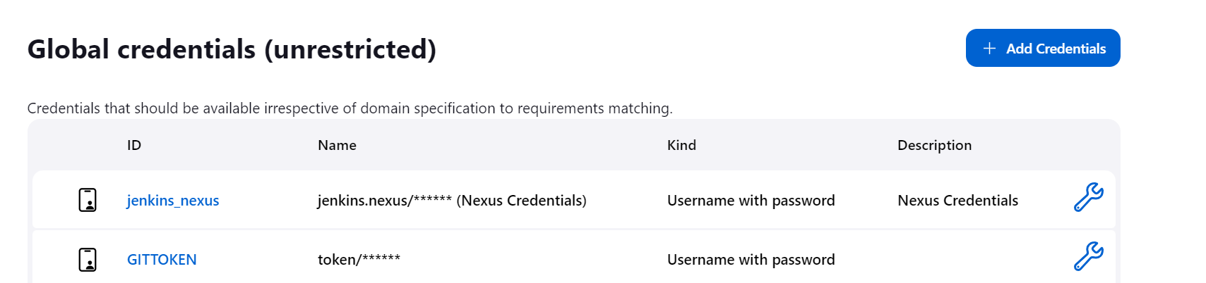

* On Credentials page, select option Username with Password, add your username in field & copy the access token to the password field & save the credentials.

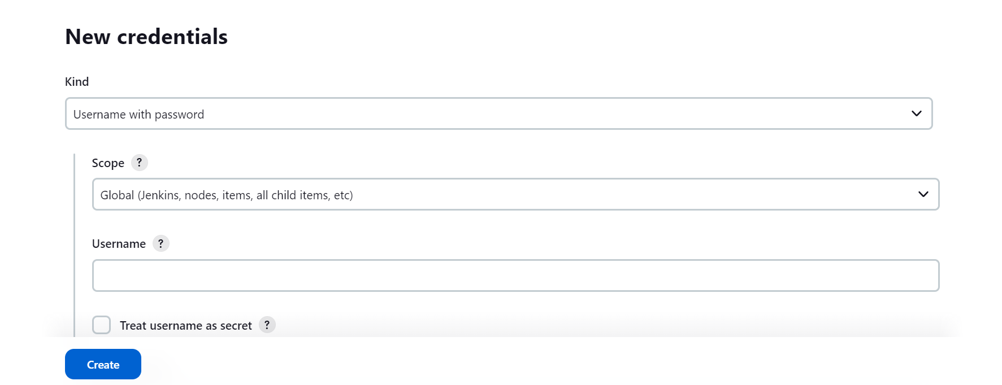

* Finally, the added credentials can be used into Pipeline as below.

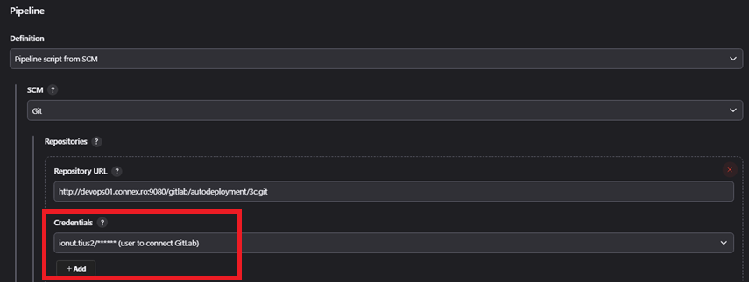

# **Nexus Upload Pipeline**

* This pipeline performs following tasks –
  + Pull & create a copy of release artifacts from AMDOCS servers to RO server named Alonso.
  + Copy release artifacts from Alonso to Jenkins temporary workspace.
  + Run this Workspace copy against specific set of rules defined in shell script to restructure, versionize & load it to nexus.
  + Clean & release Workspace memory post successful or unsuccessful action.
  + Current structing of deliverables from AMDOCS.

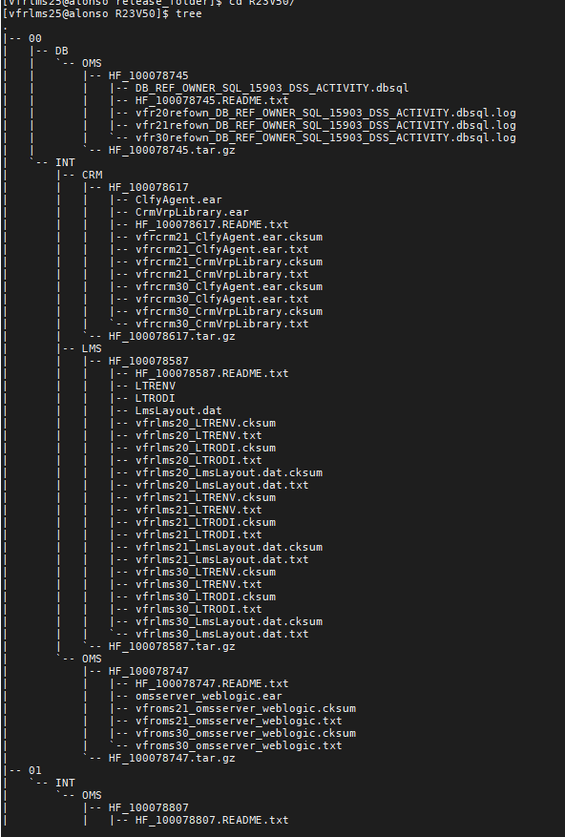

* + - Snapshot post versioning & loading into Nexus.

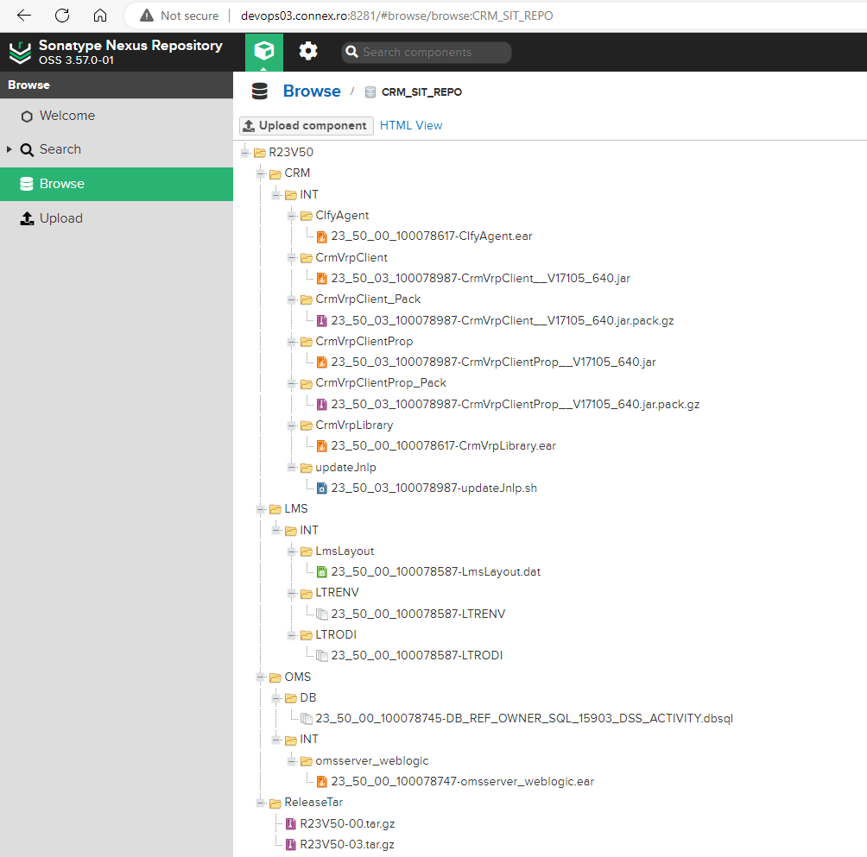

* + - The CRM_Nexus_Upload Pipeline takes 2 inputs namely ***Release number and Sub Release number*** which needs to be Versionize & loaded to nexus.

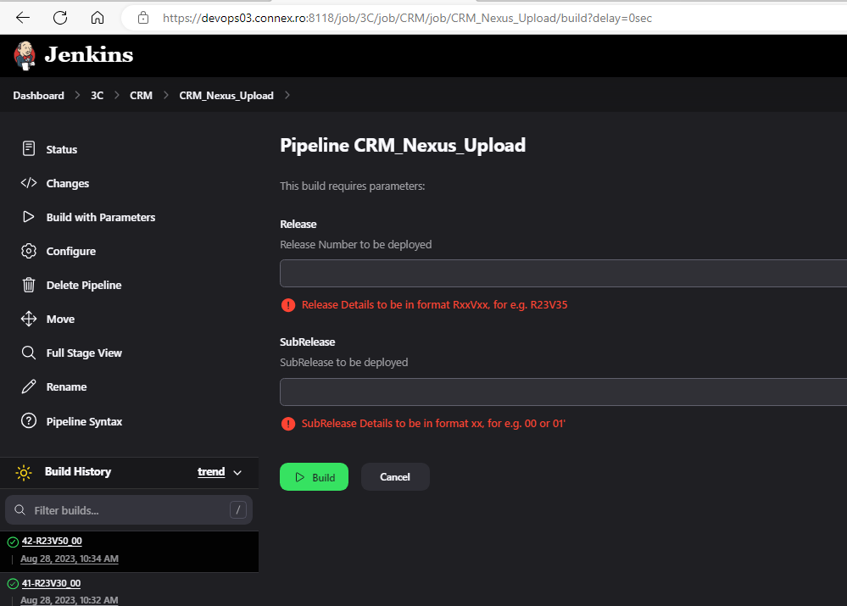

* + - Snapshot below showing different stages of CRM_Nexus_Upload pipeline post run.

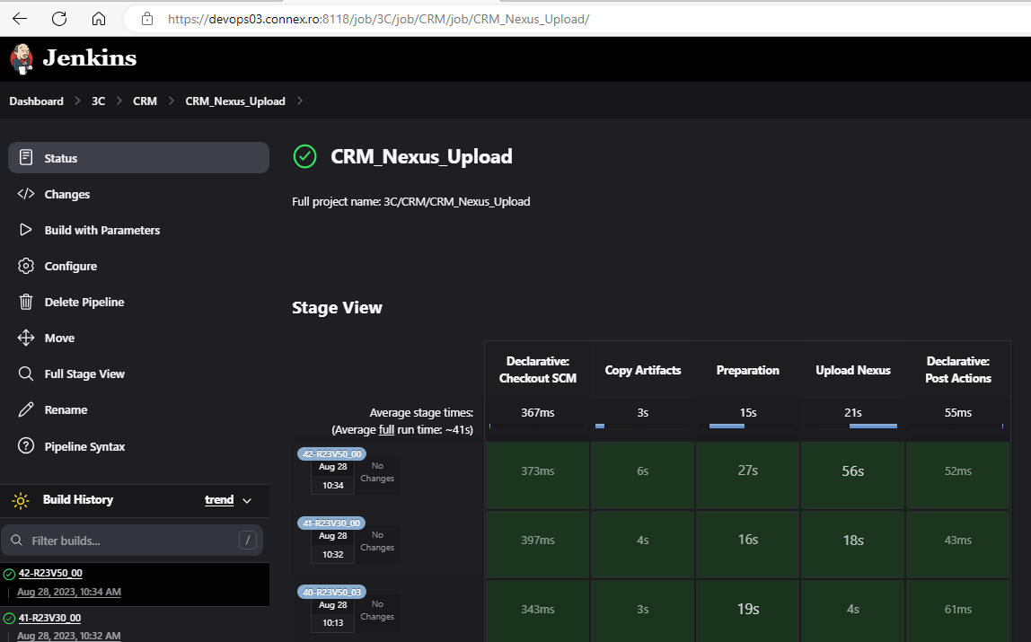

# **E2E Deployment Pipeline**

* + This pipeline is used to deploy necessary files from given release & SubRelease.
  + This pipeline needs to be used post CRM_Nexus_Upload Pipeline as this Pipeline pulls data from Nexus for deployment.
  + Pipeline performs below task –
    - Download release artifact tar file for given Release & Sub Release.
    - Extract artifacts into folder with Release number in Jenkins Workspace.
    - Perform Deployment of respective application based on files available.
    - CRM_Deployment Pipelines takes 3 inputs parameters namely Release, Sub Release & Environment on which deployments needs to be performed.

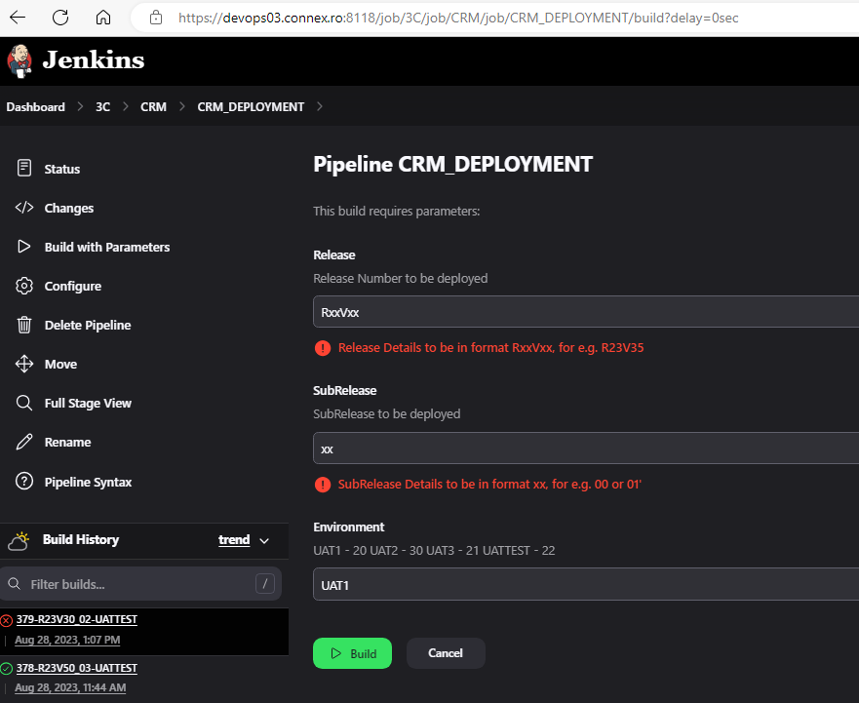

* Once given requirement inputs, Pipeline will Validate the input & perform below stages based on the files available for deployment.

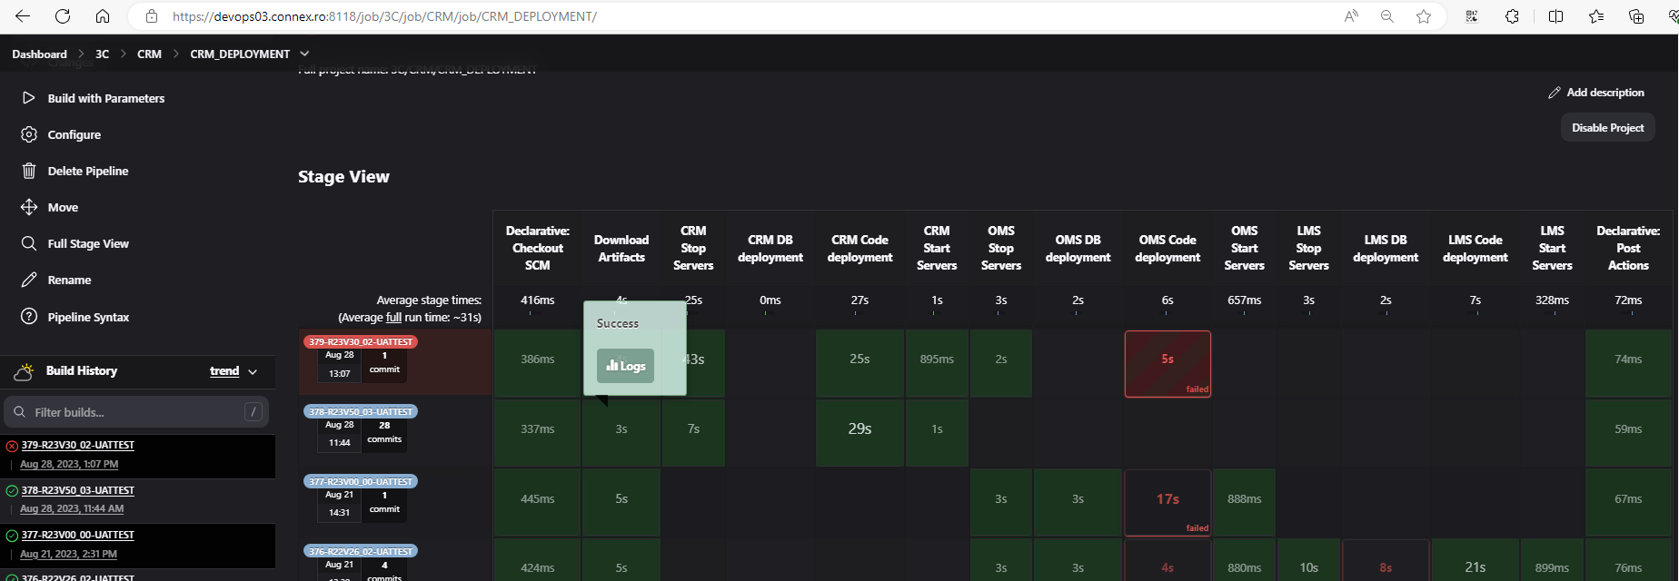

# **Individual Module Deployment Pipelines**

* CRM_MODULE_DEPLOYMENT is set of Independent Pipelines for modules (CRM, OMS, LMS) which can be used as fallback pipeline when E2E pipeline failure happens, and we don’t need any components to be redeployed.
* The implementation logic is identical as E2E pipeline of UAT.

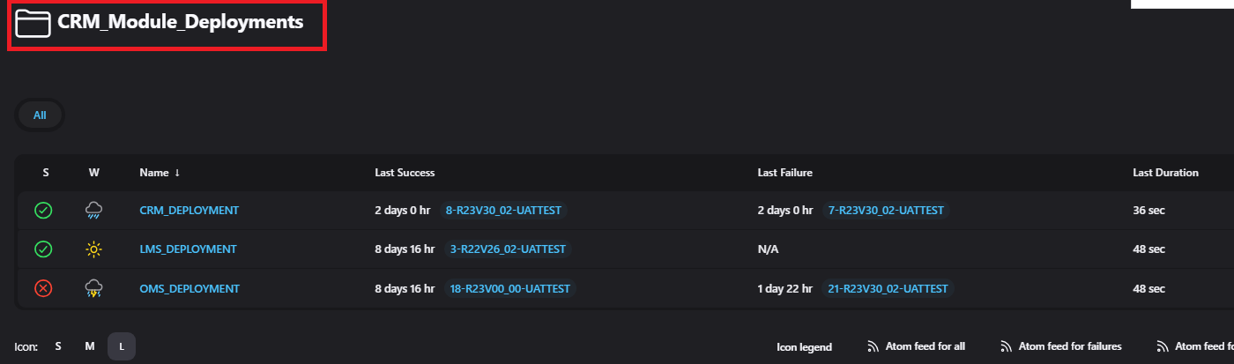

# **PET Deployment Pipeline**

* This Pipeline is specifically created for PET Environment wherein it is required to deploy entire Release along with different SubRelease as one.
* This pipeline needs to be used post CRM_Nexus_Upload Pipeline as this Pipeline pulls data from Nexus for deployment.
* Pipeline performs below task –
  + Download all release artifact tar file for given Release based on number of sub-Release given.
    - Extract all artifacts from different tar files into folder with Release number in Jenkins Workspace.
    - Perform Deployment of lates files from respective application based on files available.
    - CRM_FULLRELEASE_DEPLOYMENT Pipelines takes 3 inputs parameters namely Release, Total number of Sub Releases & Environment on which deployments needs to be performed.

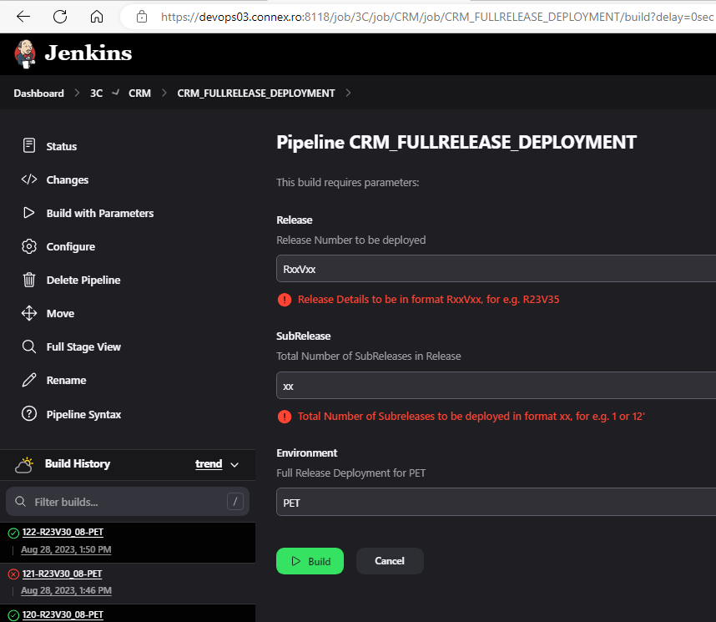

# **Report Generation Pipeline**

* This Pipeline is specifically created for generating list of latest files to be deployed from given set of multiple subrelease in given Release.
* This pipeline needs to be used post CRM_Nexus_Upload Pipeline as this Pipeline pulls data from Nexus for Report generation.
* Pipeline performs below task –
* Download all release artifact tar file for given Release based on number of sub-Release given.
* Extract all artifacts from different tar files into folder with Release number in Jenkins Workspace.
* Generate report based on the sub releases contain for given release for all component CRM/OMS/LMS
* CRM_LatestFileToDeploy_Report Pipelines takes 2 inputs parameters namely Release, Total number of Sub Releases.

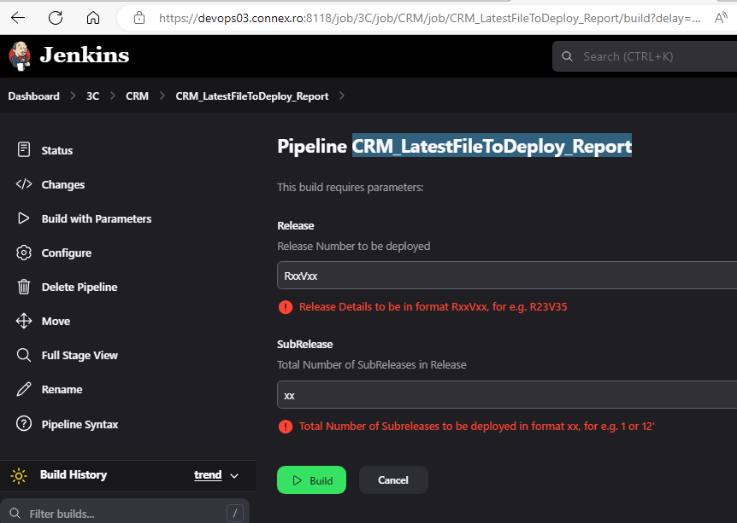

* Once given required inputs, Pipeline will Validate the input & perform below stages based on the files available for deployment.

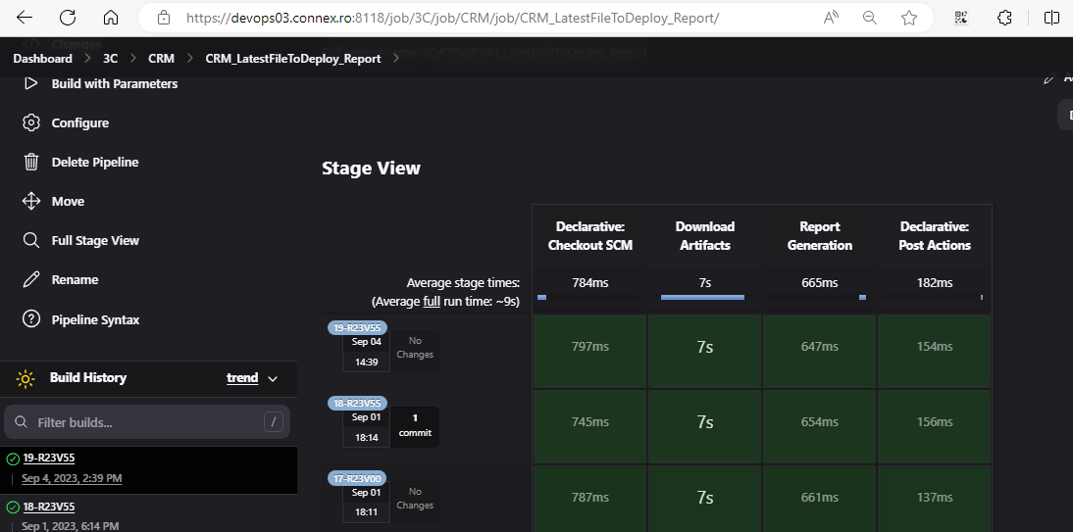

* Once given requirement inputs, Pipeline will Validate the input & perform below stages based on the files available for deployment.

